**Login test case**

**Goal:**

As a tester, I want to verify if the Login form is correct filled and working properly.

**Background:**

Login page is responsible to make a user Login.

**Steps to Reproduce**

1. Go to <https://www.find-a-house.nl/en/home> and click on the menu bar.

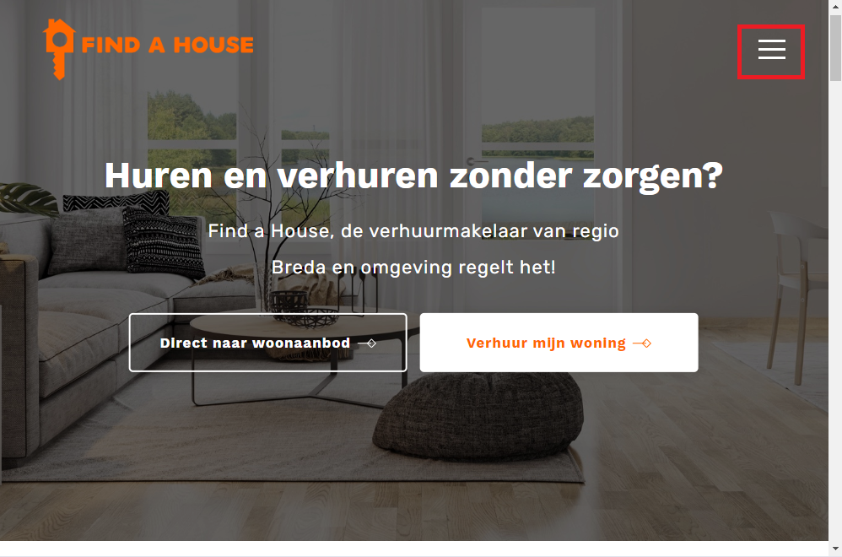

2. Click on the “Inloggen” Button to open the Login form.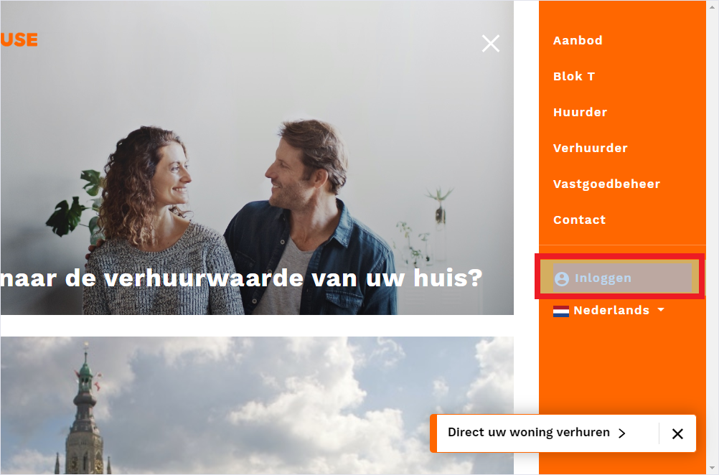

5. Fill in with correct information then click on “Inloggen”.

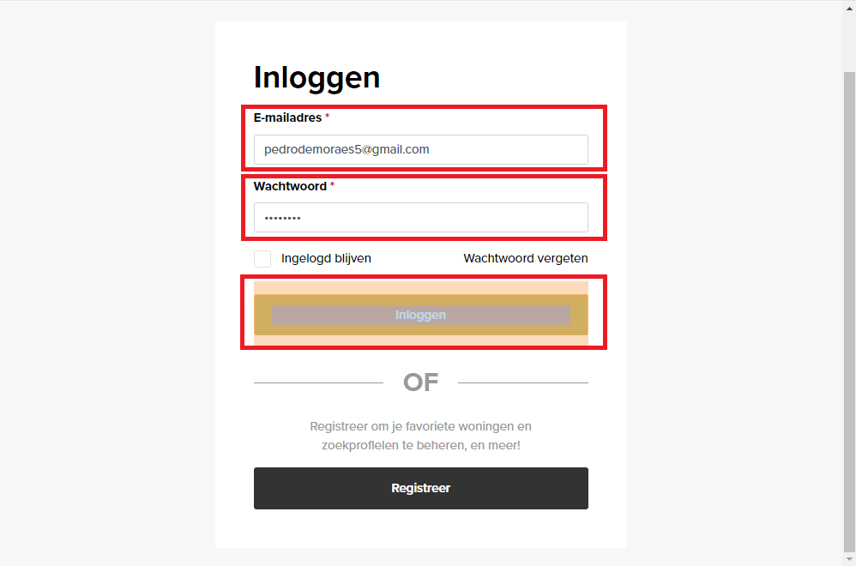

6. Login is effectuated and the Main page will be open.

